TS C004 V2.1.0 (1999-10)
Technical Specification
CWTS

Contents

China Wireless Telecommunication Standard
(CWTS);

Working Group 1 (WG1);

UE Procedures in Idle Mode

1. Scope 4
2. References 4
3. Definitions, abbreviations and symbols 5
3.1 Definitions 5
3.2 Abbreviations 6
3.3 Symbols 6
4. General description of Idle mode 7
4.1 Overview 7
4.2 Functional division between AS and NAS in Idle mode 8
4.3 Service type in Idle mode 9
5. Process descriptions 11
5.1 PLMN selection and reselection 11
5.2 Cell selection and reselection 11
5.2.1 Cell Selection Procedure 11
5.2.1.1 Description 11
5.2.1.2 Criteria 12
5.2.2 Immediate Cell Evaluation Procedure 13
5.2.2.1 Description 13
5.2.2.2 Criteria 13
5.2.3 Cell Reselection Procedure 14
5.2.3.1 Description 14
5.2.3.2 Intra-Frequency Cell Reselection Criteria 14
5.2.3.3 Inter-Frequency Cell Reselection Criteria 14
5.2.3.4 Inter Radio Access System Cell Reselection Criteria 14
5.2.3.5 Cell reselection parameters in system information broadcasts 15
5.2.4 ODMA probing sub-process 15
5.2.4.1.1 ODMA probing state machines 15
5.2.5 Barred Cells and Access Control 17
5.2.6 Regional Provision of Service 17
5.3 Location Registration 18
6. Broadcast information receiving 19
6.1 Reception of System Information 19
6.2 Cell Broadcast 19
7. Idle mode measurements 19
8. Discontinuous Reception 20
9. Multicast services 20
9.1 State diagram between the multicast service and DSCH 20
9.1.1 MT_Null State 21
9.1.2 MT_Monitor State 21
9.1.3 MT_Saving State 21
9.1.4 MT_Active State 22
10. Examples of Procedures 23
10.1 NAS initiated change of system information 23
10.2 System Information Update to NAS 24
10.3 CN originated paging in idle mode 25
10.4 PLMN Selection, automatic mode, normal case 26
10.5 PLMN Reselection, automatic mode 27
10.6 PLMN Reselection, manual mode 28
10.7 PLMN Selection, automatic mode, selected PLMN not found 29
10.8 NAS Controlled Cell Selection 29
10.8.1 Execution in Access Stratum 29
10.8.2 Execution in Non-Access Stratum 30
11. History 31

- Scope

The present document shall describe the overall idle mode process for the UE and the functional division between the non-access stratum and access stratum in the UE. The UE is in idle mode when the connection of the UE is closed on all layers, e.g. there is neither an MM connection nor an RRC connection.

This document presents also examples of inter-layer procedures related to the idle mode processes and describes idle mode functionality of a dual mode TD-SCDMA/GSM UE.

- References

The following documents contain provisions which, through reference in this text, constitute provisions of the present document.
- References are either specific (identified by date of publication, edition number, version number, etc.) or non-specific.
- For a specific reference, subsequent revisions do not apply.
- For a non-specific reference, the latest version applies.
- A non-specific reference to an TS shall also be taken to refer to later versions published as an EN with the same number.

[1] ETSI GSM TS 03.22, “Functions related to Mobile Station in idle mode and group receive mode”
[2] CWTS TS C001: “Radio Interface Protocol Architecture”
[3] CWTS TS C003: “UE Functions and Inter-Layer Procedures in Connected Mode”
[4] CWTS TS C102: “Physical channels and mapping of transport channels onto physical channels (TD-SCDMA)
[5] CWTS TS C106: “Physical layer - Measurements (TD-SCDMA)”
[6] CWTS TS C203: “RRC Protocol Specification”
- Definitions, abbreviations and symbols

Definitions

Acceptable Cell This is a cell that the UE may camp on to make emergency calls. It must satisfy certain conditions.

Allowable PLMN This is a PLMN which is not in the list of forbidden PLMNs in the UE.

Available PLMN This is a PLMN where the UE has found a cell that satisfies certain conditions.

Camped on a cell The UE is in idle mode and has completed the cell selection/reselection process and has chosen a cell. The UE monitors system information and (in most cases) paging information. Note that the services may be limited, and that the PLMN may not be aware of the existence of the UE within the chosen cell.

DRX Discontinuous Reception.

DRX cycle The individual time interval between reading initial paging information for a specific UE.

Home PLMN This is a PLMN where the Mobile Country Code (MCC) and Mobile Network Code (MNC) of the PLMN identity are the same as the MCC and MNC of the IMSI.

Initial paging information This information indicates if the UE need to continue to read more paging information and eventually receive a page message.
Initial paging occasion The paging occasion the UE use as starting point for its DRX cycle.

Location Registration (LR) The UE registers its presence in a registration area, for instance regularly or when entering a new registration area.

LSA Localised Service Area. A LSA is an operator-defined group of cells for which specific access conditions applies. This may correspond to an area in which the Core Network offers specific services. A LSA may be defined within a PLMN or globally. Therefore, a LSA may offer a non-contiguous radio coverage.

LSA exclusive access cell A UE may only camp on this cell if the cell belongs to the LSAs to which the user has subscribed. Nevertheless, if no other cells are available, the UE of non-LSA users may originate emergency calls from this cell.

LSA ID Localised Service Area Identity.

LSA only access When LSA only access applies to the user, the UE can only access cells that belong to the LSAs to which the user has subscribed. Outside the coverage area of the subscribed LSAs, the UE may camp on other cells and limited services apply.

LSA preferential access cell A LSA preferential access cell is a cell which is part of the LSA. UEs of users that have subscribed to a LSA of a LSA-preferential-access cell have higher priority to resources than non-LSA users in the same cell. The availability of LSA preferential access cells impact the following procedure(s):

- radio resource allocation (controlled by RAN-Access Stratum). This function is out of the scope of the standards.

Maximum DRX cycle The time interval for the longest possible DRX cycle in a cell.

Paging occasions The time instances where it is possible to receive initial paging information

Radio Access Mode Mode of the cell, FDD or TDD

Radio Access System UMTS, GSM,TD-SCDMA etc.

Registered PLMN (RPLMN) This is the PLMN on which the UE has performed a location registration successfully.

Registration Area A (NAS) registration area is an area in which the UE may roam without a need to perform location registration, which is a NAS procedure.

Selected PLMN This is the PLMN that has been selected by the non-access stratum, either manually or automatically.

Suitable Cell This is a cell on which an UE may camp. It must satisfy certain conditions.
[Note: These certain conditions are FFS.]

Visited PLMN of home country This is a PLMN, different from the home PLMN, where the MCC part of the PLMN identity is the same as the MCC of the IMSI.

Abbreviations

AS Access Stratum
BCCH Broadcast Control Channel
CN Core Network
DSCH Downlink Shared Channel
FDD Frequency Division Duplex
GC General Control (SAP)
GPRS General Packet Radio System
GSM Global System for Mobile
IMSI International Mobile Subscriber Identity
MCC Mobile Country Code
MM Mobility Management
MNC Mobile Network Code
NAS Non-Access Stratum
ODMA Opportunity Driven Multiple Access
ORACH ODMA Random Access Channel
PCH Paging Channel
PLMN Public Land Mobile Network
RAN Radio Access Network
RRC Radio Resource Control
SAP Service Access Point
TDD Time Division Duplex
TD-SCDMA Time Division Synchronous Code Division Multiple Access
UE User Equipment
UE_{R} User Equipment with ODMA relay operation enabled
UMTS Universal Mobile Telecommunications System
UTRA UMTS Terrestrial Radio Access
UTRAN UMTS Terrestrial Radio Access Network

Symbols
- General description of Idle mode

[NOTE: The Idle mode in TD-SCDMA also includes the Idle mode of GSM. Further details are invited.]

Overview

When a multi-mode UE is switched on, it attempts to make contact with a public land mobile network (PLMN) using a certain radio access system.

The particular PLMN to be contacted may be selected either automatically or manually.

The UE looks for a suitable cell of the chosen PLMN and chooses that cell to provide available services, and tunes to its control channel. This choosing is known as "camping on the cell". The UE will then register its presence in the registration area of the chosen cell if necessary, by means of a location registration procedure.

If the UE finds a more suitable cell, it reselects onto that alternative cell of the selected PLMN and camps on that cell. If the new cell is in a different registration area, location registration is performed.

If necessary, the UE will look for more suitable cells on other PLMNs at regular time intervals, which is referred to as PLMN-reselection. Particularly, in the home country of the UE, the UE will try to get back to its Home PLMN.

If the UE loses coverage of a PLMN, either a new PLMN is selected automatically (automatic mode), or an indication of which PLMNs are available is given to the user, so that a manual selection can be made (manual mode).

Registration is not performed by UE’s only capable of services that need no registration.

The purpose of camping on a cell in idle mode is fourfold:

- It enables the UE to receive system information from the PLMN.

- When registered and if the UE wishes to initiate a call, it can do this by initially accessing the network on the control channel of the cell on which it is camped.

- If the PLMN receives a call for the registered UE, it knows (in most cases) the registration area of the cell in which the UE is camped. It can then send a "paging" message for the UE on control channels of all the cells in the registration area. The UE will then receive the paging message because it is tuned to the control channel of a cell in that registration area and the UE can respond on that control channel.

- It enables the UE to receive cell broadcast messages

If the UE is unable to find a suitable cell to camp on, or the USIM is not inserted, or if the location registration failed, it attempts to camp on a cell irrespective of the PLMN identity, and enters a "limited service" state in which it can only attempt to make emergency calls.

The idle mode tasks can be subdivided into three processes:

- PLMN selection and reselection;
- Cell selection and reselection;
- Location registration.

The relationship between these processes is illustrated in the Figure 1.
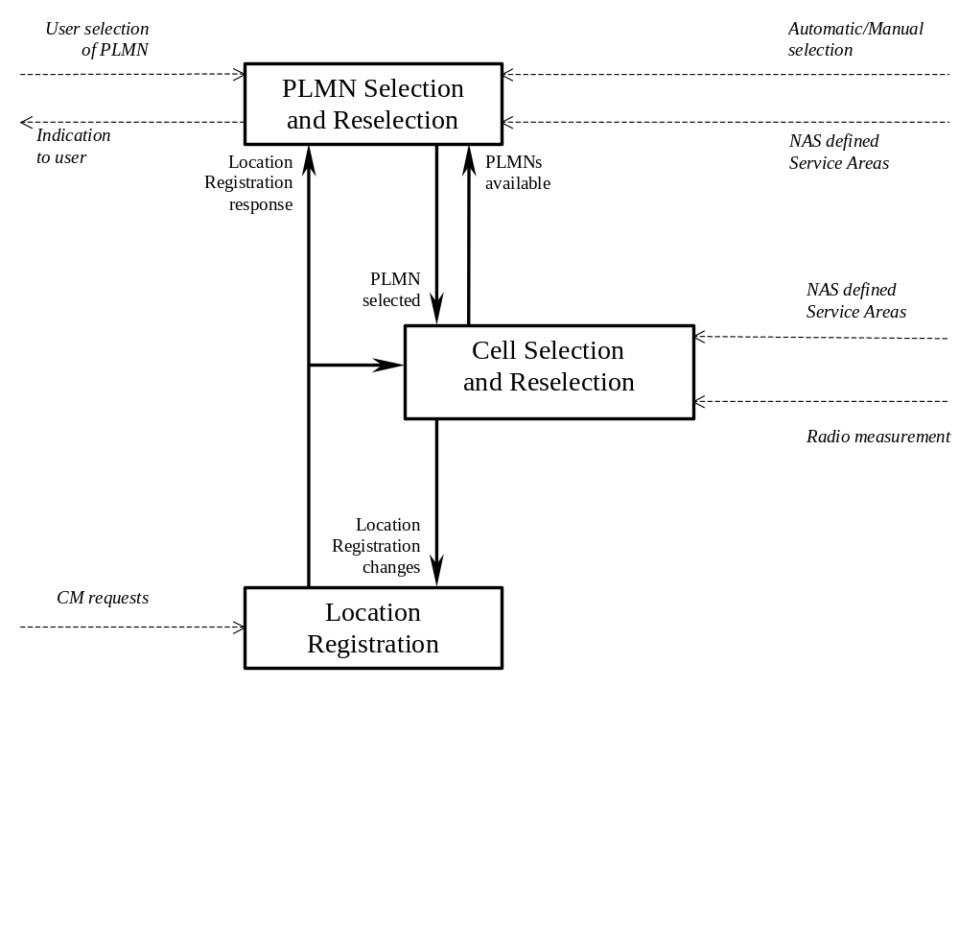
Figure 1. Overall Idle Mode process.
[Note: The prioritization of radio access systems and the impact of NAS defined service areas is FFS.]

Functional division between AS and NAS in Idle mode

Table 1 presents the functional division between UE non-access stratum (NAS) and UE access stratum (AS) in idle mode. The primary purpose of this functional division is to serve as a basis for the work division between CWTS L23 and other groups. Examples of different idle mode procedures are presented in chapter 10.

Idle Mode Process | UE Non-Access Stratum | UE Access Stratum
PLMN Selection and Reselection | Maintain a list of PLMNs in priority order. Request AS to select a cell either belonging to the PLMN having the highest priority (in automatic mode) or belonging to the manually selected PLMN.  In automatic mode, if a PLMN with higher priority is found, request AS to select a cell belonging to that PLMN. | Report available PLMNs to NAS on request from NAS or autonomously.
Cell  Selection | Control cell selection by for example, maintaining lists of forbidden registration areas and a list of NAS defined service areas in priority order. | Perform measurements needed to support cell selection.  Detect and synchronise to a broadcast channel. Receive and handle broadcast information. Forward NAS system information to NAS.  Search for a suitable cell belonging to the PLMN requested by NAS. The cells are identified with PLMN identity in the system information. Respond to NAS whether such cell is found or not.  If such a cell is found, the cell is selected to camp on.
Cell  Reselection | Control cell reselection by for example, maintaining lists of forbidden registration areas and a list of NAS defined service areas in priority order. | Perform measurements needed to support cell reselection.  Detect and synchronise to a broadcast channel. Receive and handle broadcast information. Forward NAS system information to NAS.  Change cell if a more suitable cell is found.  Perform ODMA probing in an ODMA Relay Node.
Location registration | Register the UE as active after power on.  Register the UE’s presence in a registration area, for instance regularly or when entering a new registration area.  Deregister UE when shutting down. | Report registration area information to NAS.
Table 1. Functional division between AS and NAS in idle mode.

Service type in Idle mode

This chapter provides some definitions regarding the level of service that may be provided by the RAN to an UE in Idle mode.

The action of camping on a cell is generally presented as mandatory to receive some service from the cell. This notion of service should be distinguished in 3 categories, so that the network may eventually not provide all kind of services in every cells for UE in idle mode:
- Emergency calls
- Normal services (for public use)
- Operator related services
- Location service
Furthermore, the cells can be categorised according to services they can offer:

acceptable cell:
An "acceptable cell" is a cell on which the UE may camp on to originate emergency calls. Such a cell fulfils the following requirements, which is the minimum set of requirements to initiate an emergency call in a RAN network:
- the cell may or may not belong to the allowable PLMN list stored on the USIM
- the path loss between the UE and the radio site is below a threshold which is set by the operator
- the cell is not reserved for operator use only

high priority suitable cell:
A "high priority suitable cell" is a cell on which the UE may camp on. Such a cell fulfill the following requirements:
- the cell belongs to the selected PLMN
- the path loss between the UE and the radio site is below a threshold which is set by the operator
- the cell is not barred or reserved for operator use only
- the cell priority is provided by the network on the BCCH.

low priority suitable cell:
An UE may only camp on this cell if no other high priority suitable cells are available. This may be used as an example for the support of multilayered networks
barred cell:
An UE cannot camp on this kind of cell for standard services, but may eventually initiate an emergency call from this cell if no other suitable cell is available, either low or high priority.
This type of cell may be used by operators for traffic load balancing, as an example.
Whether or not the cell is barred, is provided by the network on the BCCH.
"operator only" cell:
The aim of this type of cells is to allow the operator using and test newly deployed cells without being disturbed by normal traffic. UE cannot camp on this cell, or initiate an emergency call from this cell, except for some classes of UE. The clearance for accessing to initiate a call within such a cell is part of the information stored on the USIM.
Whether or not the cell is reserved for operator use only, is provided by the network on the BCCH.

Table 2 quickly summarizes all the different cases above as well as the level of service provided by RAN, as seen from the UE in Idle mode.

 | acceptable cell | high priority suitable cell | low priority suitable cell | barred cell | operator only cell
Emergency | Y | Y | Y | Y | N
Standard | N | Y | Y (backup) | N | N
Operator | N | Y | Y | N | Y

Table 2. Summary of service provided by RAN.

- Process descriptions

PLMN selection and reselection

The non-access stratum selects a suitable PLMN. Normally, the UE operates on its Home PLMN (HPLMN). However, a visited PLMN (VPLMN) may be selected, e.g., if the UE loses coverage with its HPLMN. There are two modes for PLMN selection:

- Automatic mode - This mode utilizes a list of PLMNs in priority order. The highest priority PLMN that is available and allowable is selected.

- Manual mode - Here the UE indicates which PLMNs are available to the user. Only when the user makes a manual selection does the UE try to obtain normal service on the VPLMN.

In the automatic mode, the UE will look for more suitable PLMNs regularly, if necessary. This is referred to as PLMN-reselection. Particularly, in the home country of the UE, the UE will try to get back to its Home PLMN.

Selection of the radio access system may be part of the PLMN selection and reselection process or it may be a separate process inside NAS [FFS].

[Note: Details of the possible NAS process of the radio access system selection are out of the scope of TSG-RAN WG2.]

Cell selection and reselection

The UE selects the most suitable cell and the radio access mode based on idle mode measurements and cell selection criteria. The non-access stratum can control the cell selection, for instance in terms of a list of forbidden registration area(s) and a list of NAS defined service area(s) in priority order. In addition, NAS may also influence the radio access system to which the cell should belong. For instance, NAS may create a list of radio access systems in priority order. [FFS]

When camped on a cell, the UE regularly searches a better cell according to the cell reselection criteria. If a more suitable cell is found, that cell is selected.

The non-access stratum is informed if the cell selection and reselection results in changes in the received system information.

For normal service, the UE has to camp on a suitable cell, tune to that cell's control channel(s) so that the UE can:

- Receive system information from the PLMN

- Receive registration area information from the PLMN, e.g., location area and routing area, and,
- Identify the NAS defined service area(s) to which the serving cell belongs
- Other AS and NAS Information

- If registered,

- receive paging and notification messages from the PLMN, and,
- initiate call setup for outgoing calls or other actions from the UE.

Cell Selection Procedure

Description
The purpose of the cell selection procedure is to find the most suitable cell for the UE to camp on. A suitable cell must fulfil all the following requirements.

- The cell is part of the selected PLMN.
- The cell is not barred [details are FFS].
- The cell is not part of a forbidden registration area [details are FFS].
- The cell selection criteria are fulfilled (see below).
- The SoLSA criteria are fulfilled [FFS].

Whenever a PLMN is selected, the UE shall attempt to find the most suitable cell of that PLMN according to the following steps.

- Create a candidate list of potential cells to camp on. Two procedures are possible for searching the most suitable cell.
- Initial Cell Selection
This procedure requires no prior knowledge of which RF channels are TD-SCDMA carriers. The UE shall scan all RF channels in the TD-SCDMA band to find a suitable cell. From strongest carrier, the UE searches first for the gold code used in DwPTS. After synchronization with system the UE will read BCCH information and from the information the UE will find out which PLMNs are available. If the PLMN that NAS requested to search for is found, the search of the rest of carriers shall be stopped. After the UE has found one suitable cell for the selected PLMN, the UE shall create a candidate list, based on the measurement and BCCH information.

- Stored Information Cell Selection
This procedure requires stored carrier frequencies and gold codes information used in DwPTS from previously received measurement control information elements. After the UE has found one suitable cell for a selected PLMN the UE shall create the candidate list based on the neighbour cell measurements and BCCH information.
[Note: Setting the priorities of PLMN search and selection are FFS]

- Read the following information from the system information of each cell of the candidate list.
- Cell Barred [details are FFS]
- Registration area
- Cell selection parameters
- For each cell on the candidate list not barred or forbidden, calculate the cell selection value, S, and the quality value, Q, defined below.
- Among the cells with S > 0 choose the cell with the highest Q value to camp on.

If no suitable cells are found and the stored information cell selection procedure was used in step 1, the Initial cell selection procedure is started and the steps are repeated. If the UE is unable to find any suitable cell using the Initial cell selection procedure, it attempts to camp on any acceptable cell and enters “limited service state”.
[Note: In PLMN selection, automatic mode, this would normally result in a new PLMN selection.]

Criteria
The cell selection value, S, is defined as follows.
S=Min(MS_TXPWR_MAX, P_MAX) – (NET_RF_OUTPUT – Q) –Qmin

S Cell Selection value, (dB)
Q Quality value. The quality of the received signal, (dB or dBm) [Note: Exact unit is FFS]
Qmin Minimum required quality level in the cell (read in system information and dependent on the quantity to measure), (dB or dBm).
NET_RF_OUTPUT RF output power of the DwPTS (read in system information), (dB or dBm).
MS_TXPWR_MAX Maximum TX power level an UE may use when accessing the cell (read in system information), (dBm)
P_MAX Maximum RF output power of the UE, (dBm)

The selection of values for network controlled parameters can be optimised by means of different methods.
The cell selection criterion is fulfilled if:
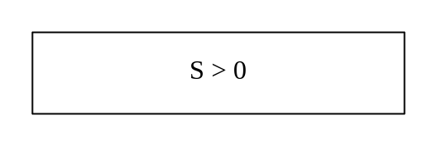

Immediate Cell Evaluation Procedure

[Note: Conditions on the use of the immediate cell evaluation procedure are FFS]

Description
The purpose of the immediate cell evaluation is to quickly find the best cell.
Triggers of immediate cell evaluation are:
- Prior to RACH transmission
- S ≤ 0
- Downlink signalling failure [details are FFS]
- Cell has become barred or forbidden [details are FFS]

The following steps are carried out when an immediate cell evaluation has been triggered.
- The candidate list of potential cells to camp on consists of the cells for intra- and inter-frequency measurements in system information of the serving cell.
- Calculate the Q value for each cell on the candidate list.
- Calculate the S value for the best cell.
- Select the neighbouring cell if the criteria defined below are fulfilled.
- If the criteria are not fulfilled, check the S value for the next best cell until the criteria defined below are fulfilled.

[Note: Whether the calculation of the Q value should require the immediate decoding (e.g. in case the UL load value is used for the calculation) of a set of neighbouring cell BCHs is FFS.]

Criteria
The UE shall perform cell reselection if the following criteria are fulfilled.
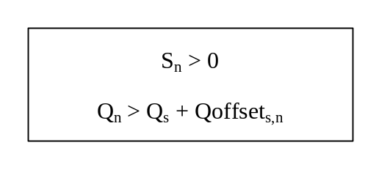
S_{n} Cell Selection value of the neighbouring cell, (dB)
Q_{n} Quality of the neighbouring cell, (dB or dBm) [Note: Exact unit is FFS]
Q_{s} Quality of the serving cell, (dB or dBm)
Qoffset_{s,n} Offset between the two cells considered in the evaluation (read in system information), (dB).
The selection of values for network controlled parameters can be optimised by means of different methods.

If more than one neighbouring cell fulfils the criteria, the UE shall choose the cell where the difference between Q_{n} and (Q_{s} + Qoffset) is highest. If no neighbouring cell fulfils the criteria, the UE shall keep the serving cell if the immediate cell evaluation was triggered prior to a RACH transmission otherwise a new cell selection shall take place.

Cell Reselection Procedure

Description
The purpose of the cell reselection is to regularly look for the best cell for the UE to camp on (according to some criteria). The serving cell is changed when a better cell is found. The criterion for a better cell is different for intra/inter-frequency and inter-RAS reselections (see below).
The following steps are carried out when evaluating cells for cell reselection.
- The candidate list of potential cells to camp on consists of the cells for intra- and inter-frequency measurements and intra-radio access system measurements in system information of the serving cell.
- Calculate the Q value and the S value for each cell in the candidate list.
- Depending on which type of cells are on the candidate list (intra-frequency, inter-frequency and inter radio access system), select the cell that fulfils the corresponding criteria best.
Better cells are prioritised in the following order when several cells fulfil their corresponding criteria:
- Intra-frequency neighbouring cells
- Inter-frequency neighbouring cells
- Inter-radio access system neighbouring cells

Intra-Frequency Cell Reselection Criteria
The criteria for a better intra-frequency cell are:
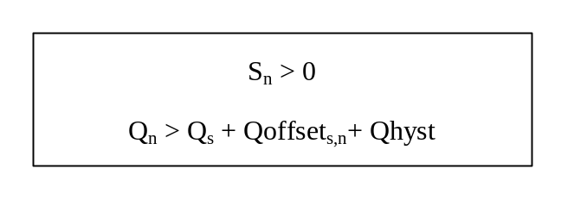
S_{n} Cell Selection value of the neighbouring cell, (dB)
Q_{n} Quality of the neighbouring cell, (dB or dBm) [Note: Exact unit is FFS]
Q_{s} Quality of the serving cell, (dB or dBm)
Qoffset_{s,n} Offset between the two cells considered in the evaluation (read in system information), (dB)
Qhyst Hysteresis value, (dB)

The timer Treselection puts a time-to-trigger criteria for cell reselection. The timer shall be started when the cell reselection criteria is fulfilled. At timer expiry, the UE shall reselect the new cell, if the cell reselection criteria are still fulfilled. The timer is reset if the cell reselection criteria are no longer fulfilled. The value of the Treselection is presented in system information.

Inter-Frequency Cell Reselection Criteria
The inter-frequency cell reselection evaluation uses the same criteria as intra-frequency cell reselections.

Inter Radio Access System Cell Reselection Criteria
Measurements on another radio access system (RAS) are not carried out unless the quality in the current radio access system is lower than a threshold, Qsearch. The quality of the target cell in the other radio access system has to exceed a threshold, Qaccept, before a reselection takes place. The following quantities are defined for inter-RAS cell reselection evaluations:
Qaccept Minimum quality required for a cell in the new system.
Qsearch Below this limit in the serving cell, the UE shall take measurements of inter-RAS cells if such entries exist in the measurement control information elements.
The UE shall consider inter-RAS cells with a quality Q > Qaccept, for reselection. The UE shall select the cell with the highest quality Q. Qaccept and Qsearch are included in the system information of the serving cell.
If the present quality is below Qsearch but no cells of the other systems reach the Qaccept quality, the cell reselection should not be performed. However, the measurements shall still continue.
If several RASs fulfils Qaccept the UE shall choose the RAS with the highest priority [FFS].

Cell reselection parameters in system information broadcasts
The selection of values for network controlled parameters can be optimised by means of different methods. Cell reselection parameters are broadcast in system information as follows:

Qoffset_{s,n}
The offset between the two cells considered in the evaluation (Qoffset_{s,n} (dB)) can be conveyed in two different ways:
1. Offsets can be included for each neighbouring cell in the intra-frequency neighbouring cell list, which is decoded from system information broadcasts in the serving cell.
2. The offset can be broadcast in each cell, and the UE decodes it from system information broadcasts in the neighbouring cell. In the case, this offset is applied for all cell relations towards that neighbouring cell (i.e. for each value on the subscript s). Decoding is done only when the cell measurement exceeds the neighbour cell decoding range. The offset is broadcast is together with an offset expiration timer, which indicates how long the offset value is valid.
[Note: Whether both 1 and 2 could be used or if only one of these alternatives is used is FFS]

Qhyst
The hysteresis value ( Qhyst (dB)) is decoded from system information broadcasts in the serving cell.

Treselection

The cell reselection timer value is decoded from system information broadcasts in the serving cell.

Decoding range

The decoding range is decoded from system information broadcasts in the serving cell.

OffsetExp

The offset expiration timer decoded from system information broadcasts in the neighbouring cell.

ODMA probing sub-process

In addition to UE cell selection process the UE_{R} will initiate or continue to evaluate the relay link via probing. The ODMA probing process state machine controls the rate of ODMA relay node probing. The ODMA probing state machines and mechanisms for controlling the rate of ODMA probing are discussed in the following section.

ODMA probing state machines

Probing is a mechanism used by the ODMA relay node to build a neighbour list which should contain at least a predefined minimum number of neighbours. The probing activity levels of an ODMA relay node may also be influenced by a number of key system parameters such as

- Number of neighbours
- Gradient information
- Path loss to neighbours
- Speed of the terminal
- Battery power level

The probing state machines are characterised by the level of probing opportunities. The objective of the probing state machines is to optimise ORACH activity to provide reduced interference and regulate power consumption. The difference between these state machines can generally be characterised by the number of ORACH channels which may be used for probing. Thus the probing opportunities within one N multiframe may vary depending upon the active state machine. Additionally, the ratio of probe transmission to reception is controlled by a probing activity parameter K. The state machines are full probing, duty maintained probing, and relay prohibited. The function of each of these state machines is described below:

Full probing
Full probing is the case where probing is allowed on every ORACH timeslot within a N multiframe. The UE_{R} will probe on the ORACH at a rate defined by the probing activity parameter K.

Duty Maintained probing
The duty maintained probing is the case where probing is allowed on M slots of an N multiframe. The UE_{R} will probe on the M ORACH slots in an N multiframe at a rate defined by the probing activity parameter K.

Relay Prohibited
In this mode the UE_{R} would cease all of its ODMA probing activities and will fall into standard TD-SCDMA operation.
per N ×7 multiframe.
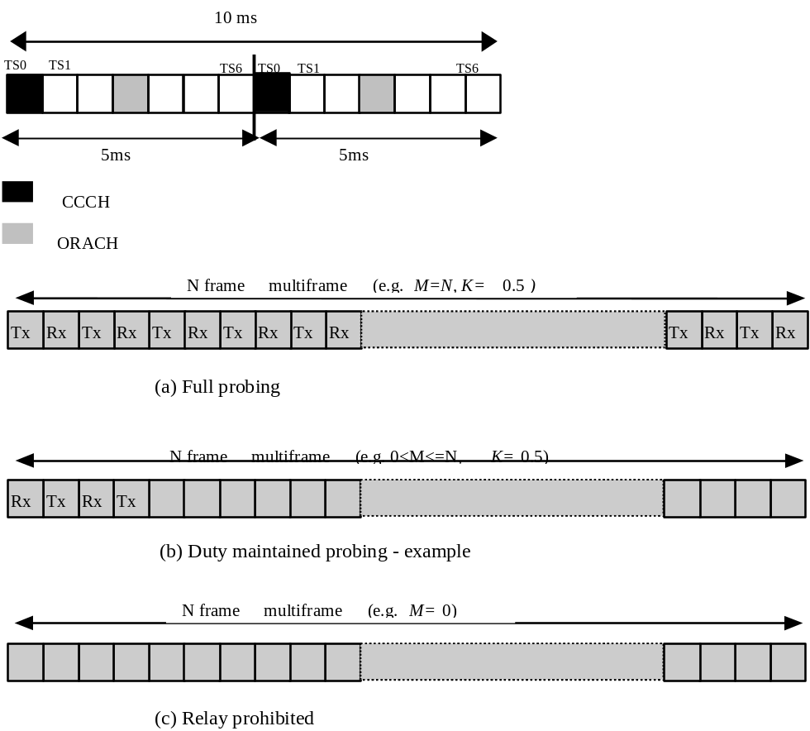

Figure 2. Probing state machines and mechanism.

Note that the distribution of probing opportunities within a multiframe may not necessarily be consecutive and located at the beginning of a multiframe.

A practical illustration of these probing state machines within the ODMA system is shown in Figure 3.

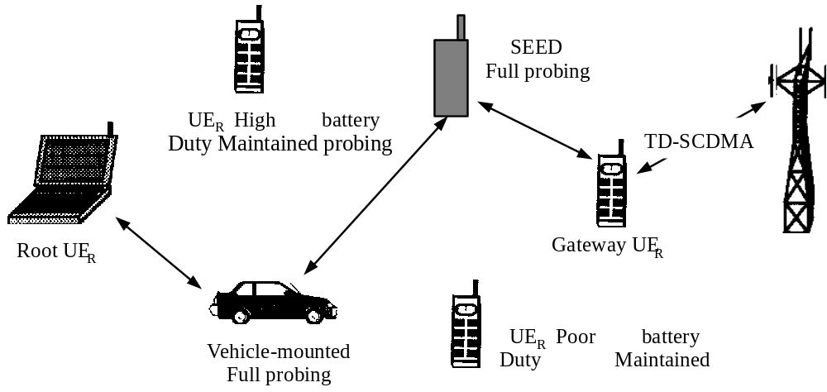

Figure 3. Illustration of probing process assignment.

Barred Cells and Access Control

In some cases operators can bar some UEs to access to system. For example there are too many UEs in a cell or the cell is reserved for “operator only” or reserved for “handovering only”. Whether the cell is barred or not is provided by the network on the BCCH.

- “Operator only” cell
When selecting or reselecting a cell UE cannot camp on this cell, even initiating an emergency call from this cell is barred, except for some special classes of UEs. The aim of this type of cells is to allow the operator using and test newly deployed cells without being disturbed by normal traffic. The clearance for accessing to initiate a call within such a cell is part of the information stored on the USIM.
- “Handovering only” cell
The cells are only used as handovering. In idle mode an UE is not approved to camp on this kind of cells. But in connect mode an UE may handover into it. Whether in idle mode or in connect mode neighbouring cell measurement must include this cell.
- Other kind of barred cell
There are some reasons for an operator to bar a cell. An UE cannot camp on this kind of cell for standard services, but may eventually initiate an emergency call from this cell if no other suitable cell is available. The operator can use this kind of manner to balance traffic load.
The priority is another kind of manner for operator to balance traffic load. The priority is divided into two grades, high priority and low priority. Usually an UE ought to camp on a high priority cell. If there is no such a high priority cell an UE is allowed to camp on a low priority cell for normal service.

Also the access control classes is used for balancing traffic load. If the network is overload the operator may decide to restrict access from some UEs and for this reason the access control mechanism is provided. At subscription one or more access control classes are allocated to the subscriber and stored in the USIM. The information providing all authorized classes is broadcast on the BCCH. This information is modified dynamically and therefore the UE has to check the BCCH before each attempt to access. When selecting or reselecting a cell an UE shall not reject a cell for camping on because access on that cell is not allowed.

Regional Provision of Service

Many kinds of services are provided by TD-SCDMA system. But not all the services are available in every region or cell. What kinds of services are provided in the cell are broadcast in BCCH except for some basic services. When selecting or reselecting a cell in idle mode the UE would give a cell higher priority if the cell can provide some special services, which are matched with the UE’s bearing ability.

Location Registration

When first camped on a suitable cell after power on, the non-access stratum will register the UE as active and present in the registration area of the chosen cell, if necessary.

The non-access stratum will register the UE’s presence in a registration area, for instance regularly and when entering a new registration area.

The access stratum will inform the non-access stratum in which NAS defined service area(s) the UE is located, for instance regularly and when entering a new NAS defined service area.

Prior to power off, the non-access stratum will deregister the UE, if necessary.

- Broadcast information receiving

Reception of System Information

The UE shall read the BCCH to acquire valid system information. For each acquisition, the UE will need different combinations of system information blocks broadcast on BCCH. Thus, the scheduling of the broadcast channel is done in such way that the UE knows exactly when the needed information can be found.

When any of the system information blocks are modified, the corresponding scheduling information is updated to reflect the changes in system information transmitted on BCCH. Further, a message is sent to all UEs on PCCH to indicate that a new master information block is available in the cell. Then the UE shall read the updated master information block on BCCH and if the changes are applicable for the UE, the modified system information block(s) are read as well.

Cell Broadcast
The following information are useful when an UE selects or reselects cell or accesses to system.

Note: Only very small amount of the system information are listed here. some of them are uniquely used in TD-SCDMA and some of them are new with other system, e.g. GSM. The detail broadcast information could be found in reference 6.

- Serving cell description

- SI changing indication
This information is used by UE to save power consuming. After reading this information the UE knows which system messages are changed and only reads the changed messages.
- Gold code group used in the UpPTS
When accessing to the system an UE chooses a gold code randomly from the gold code group. Different cell uses different gold code group. Which group a cell uses is broadcast in BCCH.
- RF power output
Knowing this information the UE can calculate roughly how much RF power it will use when randomly accessing to network.

- Neighbouring TD-SCDMA cell description

- Band
- Frequency
- Gold code used in DwPTS
- RF power output

- Neighbouring GSM cell description

- BCH carrier

Note: The compatibility with other system is FFS.

- Idle mode measurements

While in idle mode, a UE shall implement the cell selection and reselection procedures. These procedures make use of measurement procedures. The goals of the measurement procedures are sure that the UE is camped on a cell from which it can reliably decode downlink data and with which it has a high probability of communication on the uplink.
The UE shall search all given carriers in TD-SCDMA system, take readings of received DwPTS signal strength on each RF carriers and calculate the received level average values for each RF carriers (including the different values of DwPTSs in same RF carrier). The measurement samples must spread evenly during this period.

- Discontinuous Reception

The UE may use Discontinuous Reception (DRX) in idle mode in order to save power consumption. When DRX is used the UE needs only to monitor at one PICH Monitoring Occasion in the Paging Occasion per DRX cycle.
The DRX cycle length shall be 2^{k} *PBP frames, where k is an integer and PBP is the Paging Block Periodicity.
The UE may be attached to different CN domains with different DRX cycle lengths. In this case, the UE shall use the shortest of those DRX cycle lengths. The DRX cycle lengths for each CN domain are broadcast in RAN cells. An UE may also be assigned an individual DRX cycle length by a CN.
The UE shall use the IMSI, the Cell System Frame Number, Np (number of PICH paging occasions within a frame), Frame offset, PBP and the DRX cycle length to determine the Paging Occasions.
The Paging Occasions is the frame number:

Cell SFN = {(IMSI mod M) mod (DRX cycle length div PBP)} * PBP + n * DRX cycle length + Frame Offset
Where n = 0,1,2… as long as SFN is below its maximum value.
M is a constant used to simplify the calculations (FFS). M will depend on the coding used for IMSI. M must be significantly greater than the maximum possible DRX cycle length*Np.
The actual Paging Indicator within Paging Occasion that the UE shall read is similarly determined based on IMSI.

The PICH Monitoring Occasion is calculated by using the following formula:

PICH Monitoring Occasion = DRX Index mod Np

where DRX Index = {(IMSI mod M) div (DRX cycle length div PBP)}

Np is calculated by PICH repetition cycle and Burst Type.

The Paging Message Receiving Occasion is calculated using the following formula:

Paging Message Receiving Occasion =Paging Occasion + N_{PICH} + N_{GAP} + {(DRX Index div Np) mod N_{PCH} } *2
The value N_{PICH} is the number of frames for PICH transmission. The value N_{GAP} is the number of frames between the last frame carrying PICH for this Paging Occasion and the first frame carrying paging messages for this Paging Occasion. The value N_{PCH} is the number of Paging Groups.

- Multicast services

State diagram between the multicast service and DSCH

[NOTE: The use of DSCH for multicast services is FFS.]

The multicast service relative to the DSCH consists of the following states:

- MT_Null State
- MT_Monitor State
- MT_Saving State
- MT_Active State

Figure 5 shows the multicast state diagram relative to the DSCH. The MT_Monitor State is a state for decoding the DSCH in order to monitor its multicast control data and the MT_Saving State is a state in which the UE savings for the supporting power saving feature.

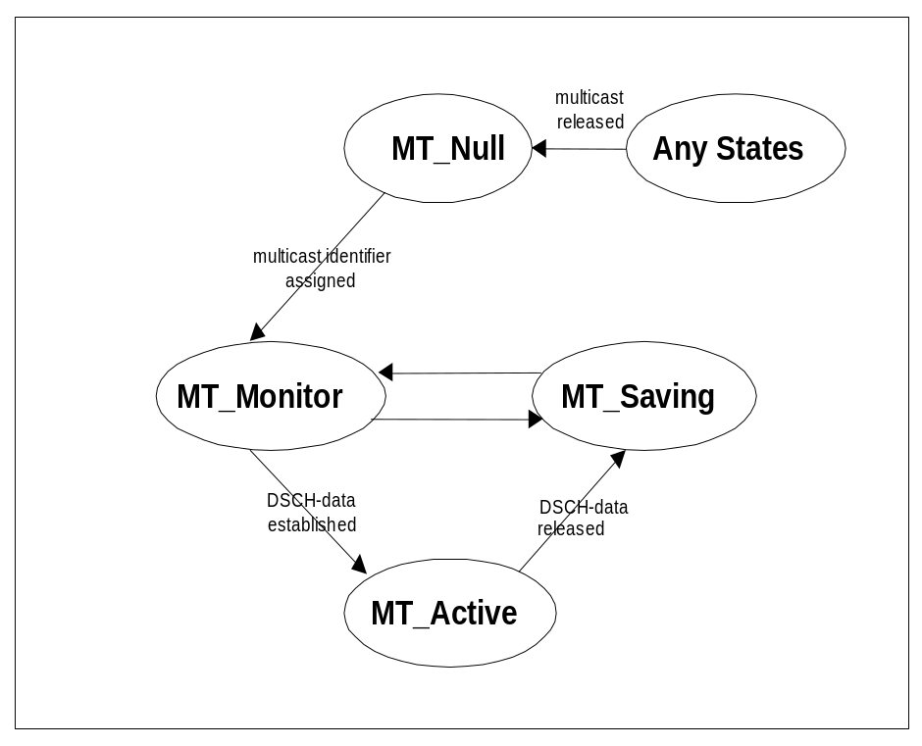

Figure 5. Multicast State Diagram relative to the DSCH, MT=MulTicast service.

MT_Null State

- Attributes
- Multicast service has not been activated.
- DSCH is not established.

- Behavior
- Waits for activation of multicast service.

MT_Monitor State

- Attributes
- DSCH is monitored in order to decode the multicast control data that contains the assigned multicast identifier.

- Behavior
- Receives the DSCH control data on DSCH and confirms the assigned multicast identifier.

MT_Saving State

- Attributes
- DSCH is not monitored for the control nor the user data.

- Behavior

FFS

MT_Active State

- Attributes
- DSCH is not monitored for the control data.
- DSCH is monitored for the user data.

- Behavior
- Receives the multicast user data on the established DSCH.

- Examples of Procedures

NAS initiated change of system information

The sequence in Figure 6 shows the change of broadcast system information initiated from the non-access stratum (NAS).

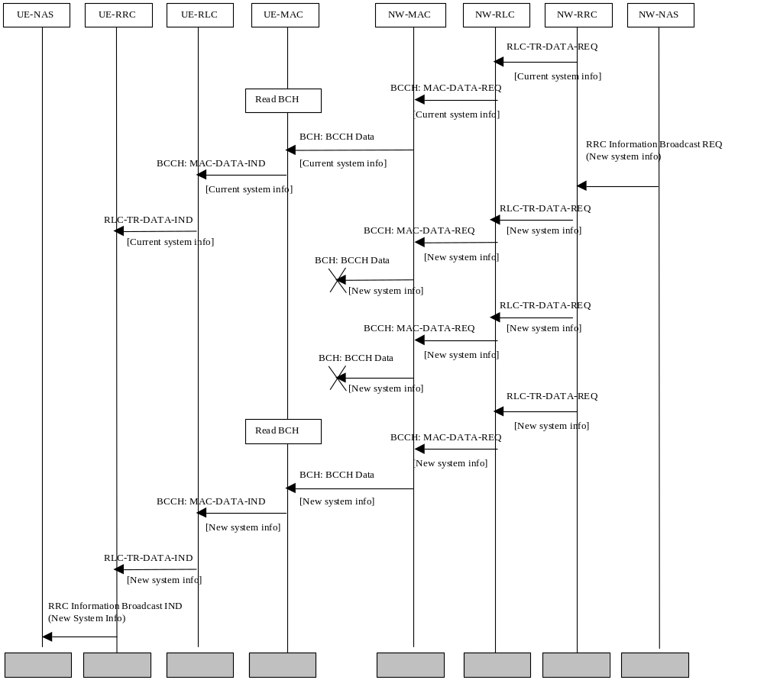

Figure 6. Example sequence, non-access stratum initiated change of broadcast system info.

A non-access stratum entity in the network issues a request for change of the broadcast system information, by issuing a RRC Information Broadcast REQ primitive over the General Control (GC) SAP.

The change in system information in this example is such that it is not necessary for the UEs to be forced to receive BCCH immediately after the change. All UEs will eventually read the new system information either at e.g. cell reselection or at UE state change.

When the UE reads system information on BCCH and the RRC layer finds out that the non-access part of the information has been changed, an RRC Information Broadcast IND primitive is issued to the non-access stratum entity in the UE over the General Control (GC) SAP.

[Note: The network may force the UEs in a paging group to read system information by sending a page request message, but this is not shown in the example above.]

System Information Update to NAS
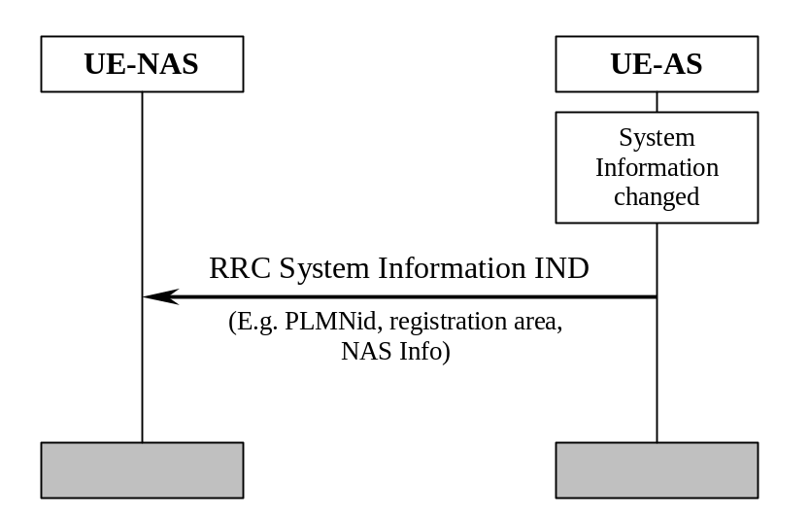

Figure 7. System Information Update to NAS.
AS sends system information to NAS when a change of system information is detected in the cell currently camped on. This happens for instance when a new cell is selected due to cell reselection. The information sent can include PLMN identity, registration area and NAS information. The NAS information includes the identity of the NAS defined service area.

CN originated paging in idle mode
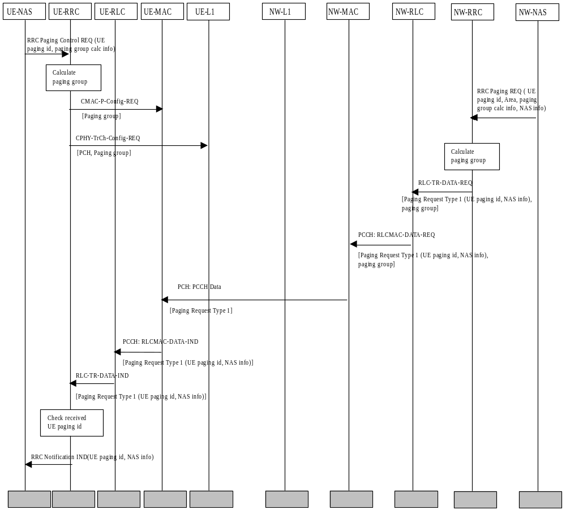

Figure 8. Example sequence of CN initiated paging request in idle mode.

Figure 8 illustrates a CN originated paging request when the UE is in idle mode.

In the UE, a NAS entity issues the primitive RRC Paging Control REQ, which tells RRC to listen to paging and notifications addressed to a given UE paging identity and on a paging group which can be calculated using information given from NAS. [Note: The paging group calculation info can e.g. be the IMSI of the UE.]

A NAS entity on the network side requests paging of an UE using the RRC Paging REQ primitive over the Nt-SAP. The primitive contains a UE paging identity, an area where the page request is to be broadcast, information for calculation of the paging group and NAS information to be transparently transmitted to the UE by the paging request.
The RRC layer calculates the paging group, and formats a Paging Request Type 1 message containing the UE paging identity and the NAS information The RRC layer then requests MAC to transmit the message on the PCH on the selected paging group.

In the UE, the RRC layer continuously monitors the paging group compares the UE paging identities in received paging request messages with its own identities. A match occurs, and in this case the UE paging identity and the NAS information is forwarded to the NAS entity of the UE.

PLMN Selection, automatic mode, normal case
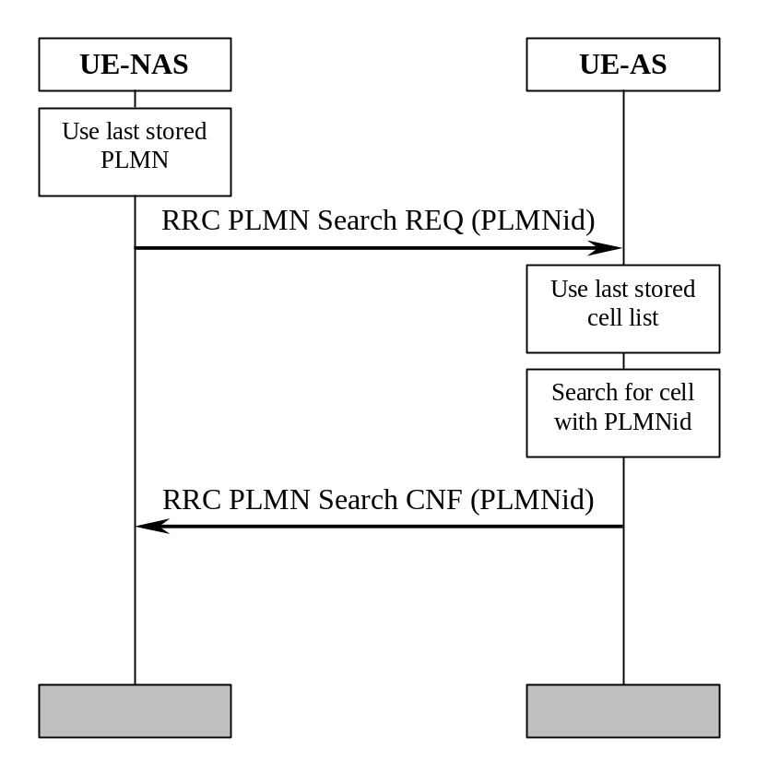
Figure 9. PLMN Selection, automatic mode, normal case.
At power-on, the non-access stratum (NAS) selects the PLMN with highest priority, possibly the last PLMN stored prior to previous power off. The access stratum (AS) is requested to find a cell belonging to that PLMN. When searching for the requested PLMN and in order to speed up the search, AS may use a list of cell information stored prior to previous power-off. When a cell belonging to the requested PLMN is found, that cell is selected and NAS is notified that the PLMN was found.

PLMN Reselection, automatic mode
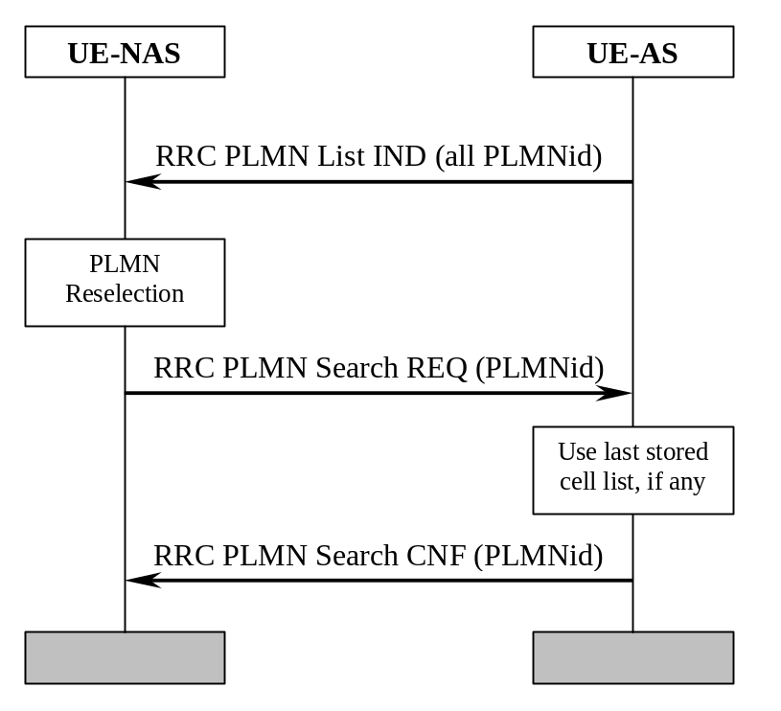

Figure 10. PLMN Reselection, automatic mode.
Triggered by, for instance, a timer, AS sends a list to NAS with all PLMNs currently available. The list includes the identities of available PLMNs and possibly information about their NAS defined service area(s). Assuming that a PLMN with higher priority is found, NAS requests AS to select a cell belonging to the PLMN with highest priority. When searching for the requested PLMN and in order to speed up the search, AS may use a list of cell information previously stored, if any. When a cell belonging to the requested PLMN is found, that cell is selected and NAS is notified that the PLMN was found.

PLMN Reselection, manual mode
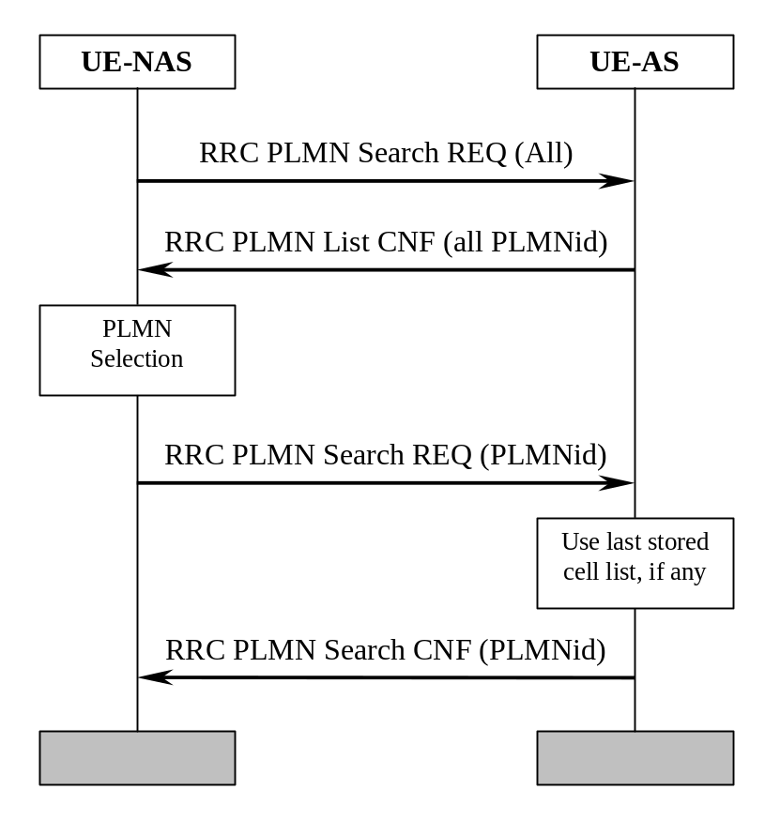

Figure 11. PLMN Reselection, manual mode.
NAS requests AS to report all PLMNs currently available, for instance as a response to a user request. AS sends a list to NAS with all PLMNs currently available. The list includes the identities of available PLMNs and possibly information about their NAS defined service area(s). Assuming that a PLMN with higher priority is selected by for instance the user, NAS requests AS to select a cell belonging to the PLMN with highest priority. When searching for the requested PLMN and in order to speed up the search, AS may use a list of cell information previously stored, if any. When a cell belonging to the requested PLMN is found, that cell is selected and NAS is notified that the PLMN was found.

PLMN Selection, automatic mode, selected PLMN not found
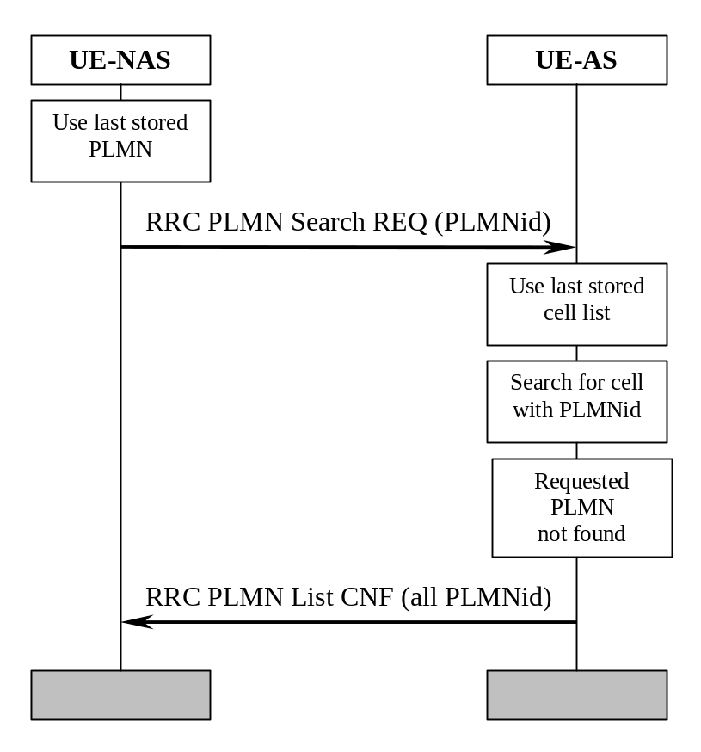

Figure 12. PLMN Selection, automatic mode, selected PLMN not found.
At power-on, the non-access stratum selects the PLMN with highest priority, possibly from the list of PLMNs stored prior to previous power off. The access stratum is requested to find a cell belonging to that PLMN. When searching for the requested PLMN and in order to speed up the search, AS may use a list of cell information stored prior to previous power-off. If no cell is found belonging to the requested PLMN, a list of available PLMNs is sent to NAS, indicating which PLMN has been temporarily chosen by AS.

NAS Controlled Cell Selection

Execution in Access Stratum
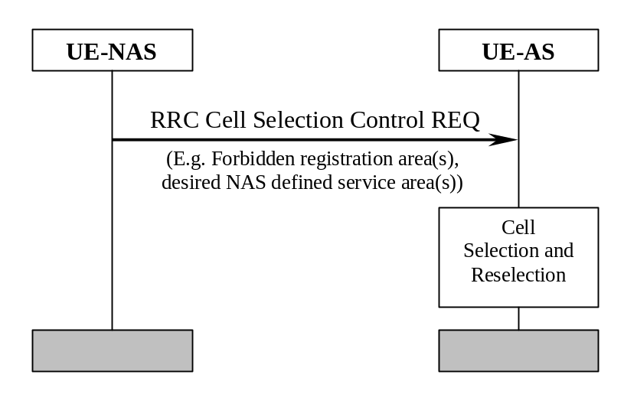

Figure 13. NAS Controlled Cell Selection, execution in AS.
NAS may influence the cell selection and reselection by sending control information to AS. This information can include, for example, lists of forbidden registration areas and a list of NAS defined service areas in priority order. The control information is used by AS in cell selection and reselection:

- Cells belonging to a forbidden registration area will only be selected if no better cell is found. At this point, the services provided the UE might be limited.
- Cells belonging to a NAS defined service area with higher priority than current service area will be considered better than the cell currently camped on. Depending on radio access mode, the most suitable cell in idle mode may not be the most suitable cell in connected mode.

Execution in Non-Access Stratum
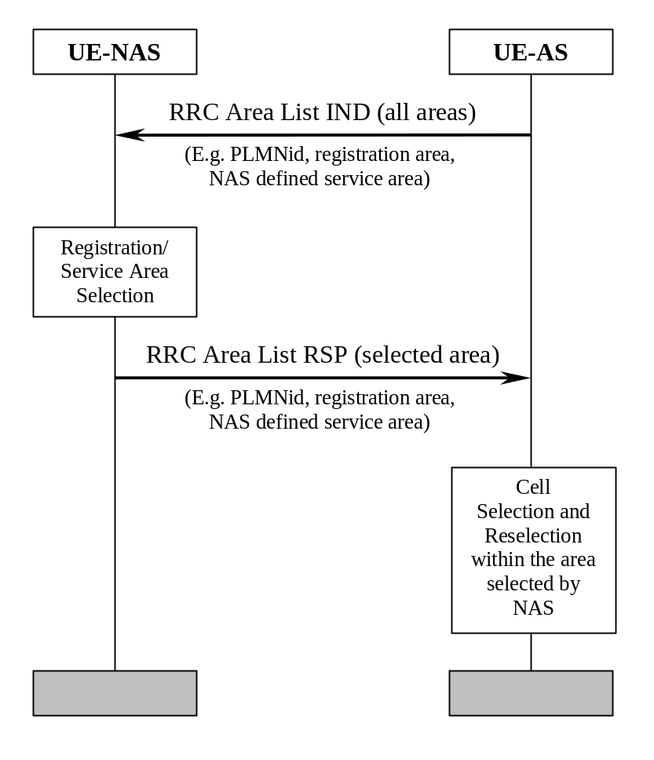

Figure 14. NAS Controlled Cell Selection, execution in NAS.
As an alternative to the example in section 10.8.1, AS sends cell selection information to NAS. This information can include PLMN identity, registration area and NAS defined service area. The information contains the full set of available registration areas and NAS defined service areas. The information is typically sent when there is a change of available areas, for instance when a neighbour cell belonging to a new registration area/NAS defined service area is found. Correspondingly, a new list of available areas is sent from AS to NAS when for instance coverage is lost from the cell currently camped on and that is the only cell belonging to the current NAS defined service area.

AS performs cell selection and reselection for the selected registration area/NAS defined service area without interaction with NAS. However, before reselecting a cell in another registration area/NAS defined service area, AS must check with NAS.
- History

Document history
Date | Version | Comment
1999-08-06 | V1.0.0 | Based on CWTS WG1 Ad Hoc1 #2 meeting in CQUPT
1999-08-29 | V2.0.0 | Based on CWTS WG1 Ad Hoc1 #3 meeting in Beijing
1999-10-14 | V2.1.0 | Document accepted by CWTS WG1 Ad Hoc1 #4 and CWTS WG1#5 in Beijing
he editor for CWTS TS C004 UE Procedures in Idle Mode is:
Li Xiaowen
Chongqing University of Posts & Telecommunications
Email: XWLI@CQUPT.EDU.CN
This document is written in Microsoft Word 97.
This document is written in Microsoft Word Version 97 SR-1.

